Mini Project Report

On

## “**EduSync Pro**”

###### Submitted to

**Ajay Kumar Garg Engineering College, Ghaziabad**



(B.Tech. Information Technology Sem 7th , 2023-24) (KIT-752 Mini Project Assessment Report)

**Submitted To :- Submitted By :-**

Mrs. Aarti Chaudhary Aradhya Priyadarshi - 2000270110021

**Dr. A.P.J. Abdul Kalam Technical University, Uttar Pradesh, Lucknow**

**ACKNOWLEDGMENT**

We would like to convey my heartfelt gratitude to Mrs. Aarti Chaudhary for her tremendous support and assistance in the completion of my project. We would also like to thank our HOD sir Mr. Rahul Sharma, for providing us with this wonderful opportunity to work on a project with the topic “**EduSync Pro**”. The completion of the project would not have been possible without their help and insights.

We would like to express our special thanks of gratitude to our friends who helped us in doing a lot of research and we came to know about so many new things, we are really thankful to them.

Secondly, we would also like to thank our parents and college who helped us a lot in finalizing this project within the limited time frame.

We have taken efforts in this project. However, it would not be possible without the kind support and help of many individuals and organizations. We would like to extend our sincere thanks to all of them.

- Aradhya Priyadarshi  
2000270110021

##### ABSTRACT

This report specifies the various processes and techniques used in gathering requirements, designing, implementing and testing for the project on college management system. The problems regarding the current system in the college was analyzed and noted. This project aims to solve some of those problems and thus, add more value to the current system. The requirements were gathered from all the stakeholders and based on that we created a requirement models and designed the software based on the based. The project was implemented in the form of a website using Python (Django Framework), HTML, CSS & Bootstrap.

Using the various resources and tools we gathered along the way, we implemented the college ERP system using some features that solve the current problems in the system such as a provision to edit the attendance and marks before locking it at the end. The software was also tested using the various testing methods and results were positive.

Thus, the results can be integrated in the current ERP system to improve it's working and solve some of the existing problems.

**INFOSYS SPRINGBOARD – Python Course Summer Training Completion Certificate**



##### CERTIFICATE

This is to certify that ARADHYA PRIYADARSHI (2000270110021) student of Bachelor of Technology , 7th Semester, Department of Information Technology of AJAY KUMAR GARG ENGINEERING COLLEGE , has pursued the Mini Project titled “EduSync Pro” under the supervision of MR. RAHUL SHARMA, Head of Department and Internal Guide MRS. AARTI CHAUDHARY and the report has been submitted in partial fulfillment of requirements for the award of Degree, Bachelor of Technology in Information Technology by AJAY KUMAR GARG ENGINEERING COLLEGE.

Internal Examiner Signature

##### CONTENTS

* Objective 7
* Introduction 8
* Introduction to the Problem Domain 9
* Why do we need an ERP? 9
* Identification of Stakeholders 10
* Problem Areas 11
* Project Scope 12
* Purpose of the Project 12
* Data Flow Diagrams
  + Class Diagram 13
  + ER Diagram 14
  + Architectural Design 15
  + Use-Case Diagram 16
* Operating Environment 17
* EduSync Pro 18
* CollegeERP System 25
  + Admin Section 26
  + Student Section 30
  + Teacher Section 32
* Source Code 36
* Conclusion 54
* References 55

##### OBJECTIVE

The objective of EduSync Pro – CollegeERP System is to allow the administrator of any organization the ability to edit and out the personal details of a student and allows the student to keep up to date his profile. It'll also facilitate keeping all the records of students, such as their id, name, mailing address, phone number, DOB etc. So all the information about a student will be available in a few seconds. Overall, it'll make Student Information an easier job for the administrator and the student of any organization.

The main purpose of this project is to illustrate the requirements of the project EduSync Pro – CollegeERP System and is intended to help any organization to maintain and manage personal data. It is a comprehensive project developed from the ground up to fulfill the needs of colleges as they guide their students. This integrated information management system connects daily operations in the college environment ranging from Attendance management to communicational means among students and teachers. This reduces data error and ensures that information is always up-to-date throughout the college. It provides a single source of data repository for streamlining your processes and for all reporting purposes. It has a simple user interface and is intuitive. This insures that the users spend less time in learning the system and hence, increase their productivity. Efficient security features provide data privacy and hence, increase their productivity.

##### INTRODUCTION

The objective of EduSync Pro – CollegeERP System is to allow the administrator of any organization the ability to edit and out the personal details of a student and allows the student to keep up to date his profile. It'll also facilitate keeping all the records of students, such as their id, name, mailing address, phone number, DOB etc. So all the information about a student will be available in a few seconds. Overall, it'll make Student Information an easier job for the administrator and the student of any organization.

The main purpose of this project is to illustrate the requirements of the project EduSync Pro – CollegeERP System and is intended to help any organization to maintain and manage personal data. It is a comprehensive project developed from the ground up to fulfill the needs of colleges as they guide their students. This integrated information management system connects daily operations in the college environment ranging from Attendance management to communicational means among students and teachers. This reduces data error and ensures that information is always up-to-date throughout the college. It provides a single source of data repository for streamlining your processes and for all reporting purposes. It has a simple user interface and is intuitive. This insures that the users spend less time in learning the system and hence, increase their productivity. Efficient security features provide data privacy and hence, increase their productivity.

##### INTRODUCTION TO THE PROBLEM DOMAIN

As we know that, a college consists of different departments, such as course departments, fees management, library, event management etc. Nowadays applications and uses of information technologies is increased as compared to before, each of these individual departments has its own computer system to do their own functionalities. By having one main system they can interact with each other from their respected system by having valid user id and password.

##### WHY DO WE NEED AN ERP ?

Nowadays, in schools and colleges, it is very difficult to manage each and everything mchauchaually. Super- vising and maintaining the whole database of a school or college can be time-consuming and challenging especially if it's done on a regular basis. So, we need to handle and manage everything smartly.

To solve this problem ERP(Enterprise Resource Planning) is used. ERP software makes it easy to track the progress of every department of school and automate different functions. With ERP every- thing can be seen on a single dashboard. The administrator can manage the college from anywhere. The possibilities of maintaining the whole database of a college with ERP software are endless.

Some of the prominent roles of ERP are:

1. Manages the office and automates different functions.
2. Helps in long-term management and planning of all departments of college.
3. Eliminates the need for having multiple management software for each department.
4. Daily activities like attendance can be digitalized and automated.
5. Leave module for teachers can be automated.

##### IDENTIFICATION OF STAKEHOLDERS

Enterprise Resource planning implementation is a difficult and complex decision where it involves people issues more than technological issues. Identification of stakeholders is a key step during the process of ERP implementation, because if done improperly, it will lead to failure of the implementation project. The stakeholders are listed below:

##### Teachers

Teachers are the key stakeholders of the college ERP. Because they are the one who manage, edit, update the contents of the database of students such as attendance, internal marks, CGPA etc... It also helps them to assign their class to other teachers when they are on leave. This makes it easier to identify who among them are free to take the class at that time. So this software help them reduce their overhead and make their tasks easier and simple.

##### Students

Students are end users of ERP software. The attendance, internals marks uploaded by the teachers are viewed by students. It helps them track their attendance status. It also helps them to communicate with teachers and their classmates. So students make up another set of stakeholders of this software.

##### Administrator

College administrator is responsible for maintaining the database of the college. They will have the privilege to modify the database i.e., to add/remove students/teachers/staff, update information regarding each of these. It is their responsibility to maintain the database of students who pass out from the college and who freshly get admission to the college. So the Administrator play a major role in the ERP.

##### PROBLEM AREAS

The problem with the ERP software is if the faculty applies for leave and wants to allocate the class to any other faculty, then the request goes to all the faculties of all the departments. This should not happen because other department faculty cannot handle the class for any other department i.e. if the faculty of Computer Science department applies for the leave and if the request is sent, it must be sent to the faculties of the Computer Science department only and not for any other department like Civil , Mechanical, EN, and so on.

When the faculty is inserting the attendance into the system, there must be a separate space for the faculty to fill what topics they have covered in the class. It will be time consuming for the faculty to enter the topic every time. So, for this purpose the software must be designed in such a way that it inserts the topic automatically. Firstly, all the topics and the duration for the faculty in which the faculty must cover must be mentioned. And then the faculty must investigate it and cover the syllabus according to the plan. This can also keep a track of the lecturer what they are teaching. If the doubts are raised by the students, then that would lead to shortage of time to cover the syllabus. So, for this purpose the faculty can have the freedom to extend the duration to cover those topics by handling extra classes when the students are free. For taking the extra class, the faculty must block in the time table and it must be visible to all the faculties of that class so that there would be no collision in handling the extra class. Once if the faculty enters the attendance and if they press lock option, then there won't be any option to change the attendance of the students. Lastly, the teachers would like it if they could enter the attendance in the class itself. This would minimize the paper work and they could update the details at any place and at any time.

##### PROJECT SCOPE

The project is designed to help the teachers and students manage their college activities. It consists of relational databases of students, departments, faculty, courses of the entire university. Using these databases, various functions that include Attendance management, marks management and leave management are provided. Within attendance management, a teacher can enter the attendance status of each student for each course with their respective dates. Similar to attendance, Internal and Semester end marks can also be entered for each student.

##### PURPOSE OF THE PROJECT

The main purpose of this project is to illustrate the requirements of the project EduSync Pro – AKGEC CollegeERP and is intended to help any organization to maintain and manage personal data. It is a comprehensive project developed from the ground up to full the needs of colleges as they guide their students. This integrated information management system connects daily operations in the college environment ranging from Attendance management to communicational means among students and teachers. This reduces data error and ensures that information is always up-to-date throughout the college. It provides a single source of data repository for streamlining your processes and for all reporting purposes. It has a simple user interface and is intuitive.

##### DATA FLOW – DIAGRAMS

Class Diagram of CollegeERP

The class diagram states the different classes involved in the software. For each class, a set of attributes and method are included. The relationship between the classes are also specified. For example, the teacher class has the attributes Id, name, phone no, address and methods such as marking attendance, declaring marks and preparing report cards. Each instance of the teacher class belongs to a department. This is specified by the relationship between Teacher and Department classes.

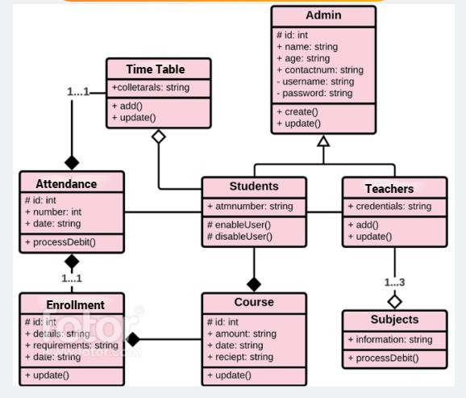

Fig.1 : Class Diagram of CollegeERP

Entity Relationship Diagram

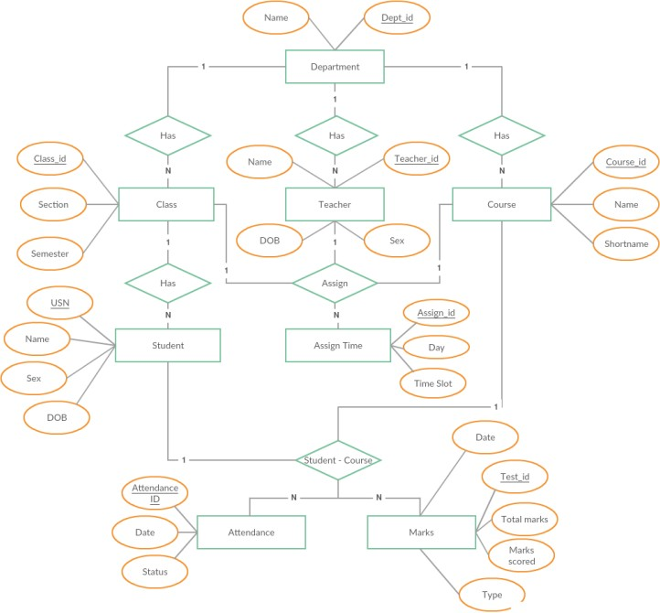

Fig.2 : Entity Relationship Diagram

Architectural Design

The ERP software requires the architectural design to represent the design of the software. Here we define a collection of hardware and software components and their interfaces to establish the framework for the development of this software. There exists number of components of the system which are integrated to form a system. The set of connectors will help in coordination, communication, and cooperation between the components. The ERP software is built for computer-based system. It exhibits the data centric style of architecture.

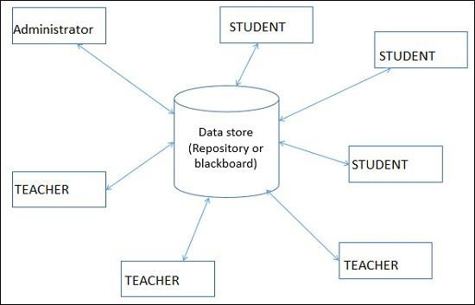

Fig.3: Architectural Style

Use Case – Diagram

A use case diagram at its simplest is a representation of a user’s interaction with the system that shows the relationship between the user and the different use cases in which the user is involved. A use case diagram can identify the different types of users of a system and the different use cases and will often be accompanied by other types of diagrams as well. The use cases are represented by either circles or ellipses.

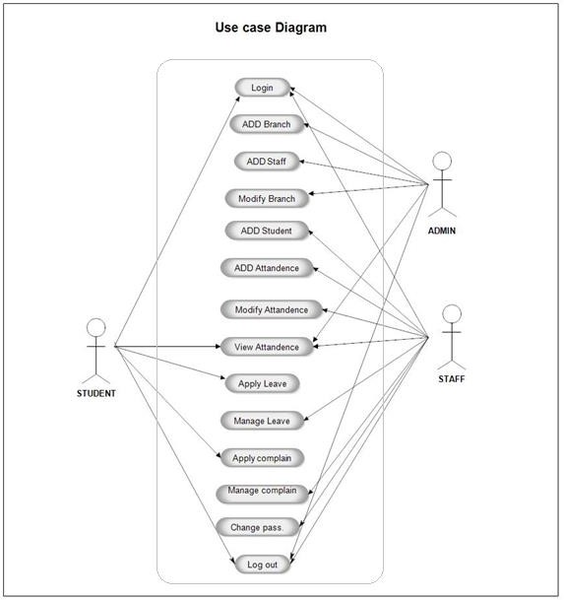

Fig.4 : Use Case - Diagram

##### OPERATING ENVIRONMENT

* The following system requirements are needed in order to run CollegeERP successfully in a system.
  + OS: Windows10
  + Database: MySQL database
  + Frontend: HTML/CSS/Bootstrap
  + Backend: Django

##### HARDWARE SYSTEM ENVIRONMENT

* i3 10th Gen. Intel Processor
* 8 GB RAM
* 256 GB SSD

# EduSync Pro

## Frontend - Overview of the Project

EduSync Pro



[AKGEC Website](https://www.akgec.ac.in/) [Google Classroom](https://accounts.google.com/v3/signin/identifier?dsh=S168243120%3A1668369986192437&continue=https%3A%2F%2Fclassroom.google.com%2Fu%2F0%2Fh&followup=https%3A%2F%2Fclassroom.google.com%2Fu%2F0%2Fh&passive=1209600&service=classroom&flowName=GlifWebSignIn&flowEntry=ServiceLogin&ifkv=ARgdvAtGhoKqWbZ1fXbvgua0_u2lqcjO6owcpFgBM0iCLPcXd6j50noG0JqG2nd7UKvO0C_JAHM_) [GeeksForGeeks](https://www.geeksforgeeks.org/) [YouTube](https://www.youtube.com/)

🙂

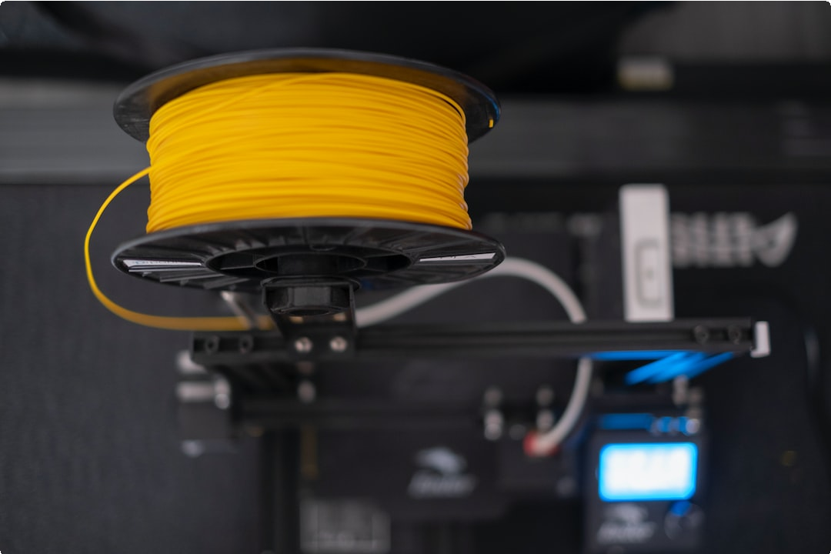

H O L A !

Innovation takes birth in sync with the evolution of customer’s expectations and demands or vice versa. Either way, organizations around the world have to continually innovate themselves

and keep up with the people’s wants. The failure to do so or being indifferent to your customer’s need will make your competitors win. And then suddenly, customers become indifferent to you- a high-risk gamble to play at.

###### AKGEC CollegeERP

[Click here to visit CollegeERP](https://web-production-853c.up.railway.app/)

### Howdy! Have you missed your college today? Don't worry! Sit back & Relax *_* Welcome to MyStudyPartner ;)

Jai Hind! Everyone, This is Aradhya Priyadarshi who has made a project on a website that will make available all the notes and important topics about

the academic related options. The name of the project is EduSync Pro.



Materials



“A reader lives a thousand lives before he dies.” – George R. R. Martin

CS

* 1. [Constitution of India - KNC501](https://drive.google.com/u/1/uc?id=1V6fkzZKzMRq3KIz5IANKrhllxZvbpko6&export=download)
  2. [Database Management System - KCS501](https://drive.google.com/u/1/uc?id=12H5Spm95m7McdQJGsCOiUsH8ZKKLAhpv&export=download)
  3. [Design & Analysis of Algorithm - KCS503](https://drive.google.com/u/1/uc?id=1tyQU53viRFqCuYztvOFD3f1VMOgiaKA_&export=download)
  4. [Human Computer Interface - KCS058](https://drive.google.com/u/1/uc?id=1c0bctjBuV9nwpq9CNfLDE8ra2RM4wS7L&export=download)
  5. [Compiler Design - KCS502](https://drive.google.com/u/1/uc?id=1FFeTet84Cr4QMcV5MPsJzOr_k4ZTxnob&export=download)
  6. [Web Designing - KCS052](https://drive.google.com/u/1/uc?id=1WjPuLIHum3duXlZu6V4Ht9yX5Ivouh37&export=download)

IT

1. [Constitution of India - KNC501](https://drive.google.com/u/1/uc?id=1V6fkzZKzMRq3KIz5IANKrhllxZvbpko6&export=download)
2. [Database Management System - KCS501](https://drive.google.com/u/1/uc?id=12H5Spm95m7McdQJGsCOiUsH8ZKKLAhpv&export=download)
3. [Design & Analysis of Algorithm - KCS503](https://drive.google.com/u/1/uc?id=1tyQU53viRFqCuYztvOFD3f1VMOgiaKA_&export=download)
4. [Human Computer Interface - KCS058](https://drive.google.com/u/1/uc?id=1c0bctjBuV9nwpq9CNfLDE8ra2RM4wS7L&export=download)
5. [Object Oriented System Design - KCS054](https://drive.google.com/u/1/uc?id=1b56ZZIynY6RY-3UiKQSyLetUmZq897XO&export=download)
6. [Web Technology - KIT501](https://drive.google.com/u/1/uc?id=1zE5EMkrOW-bsSgRyfMusYC6coxVu70Nf&export=download)

CSIT

1. [Constitution of India - KNC501](https://drive.google.com/u/1/uc?id=1V6fkzZKzMRq3KIz5IANKrhllxZvbpko6&export=download)
2. [Database Management System - KCS501](https://drive.google.com/u/1/uc?id=12H5Spm95m7McdQJGsCOiUsH8ZKKLAhpv&export=download)
3. [Design & Analysis of Algorithm - KCS503](https://drive.google.com/u/1/uc?id=1tyQU53viRFqCuYztvOFD3f1VMOgiaKA_&export=download)
4. [Human Computer Interface - KCS058](https://drive.google.com/u/1/uc?id=1c0bctjBuV9nwpq9CNfLDE8ra2RM4wS7L&export=download)
5. [Object Oriented System Design - KCS054](https://drive.google.com/u/1/uc?id=1b56ZZIynY6RY-3UiKQSyLetUmZq897XO&export=download)
6. [Web Technology - KIT501](https://drive.google.com/u/1/uc?id=1zE5EMkrOW-bsSgRyfMusYC6coxVu70Nf&export=download)

Essential Websites

“Measuring programming progress by lines of code is like measuring aircraft building progress by weight.” – Bill Gates

AKTU OneView

AKTU Portal to view result

[Click here to visit AKTU OneView](https://erp.aktu.ac.in/webpages/oneview/oneview.aspx)



AKTU ERP

AKTU Portal to manage your University data

[Click here to visit AKTU ERP](https://erp.aktu.ac.in/)



AKGEC Edumarshal

AKGEC Portal to manage your College data

[Click here to visit Edumarshal](https://beta.edumarshal.com/)

###### OUR TEAM

When the ideas are coming, we don't stop until the ideas stop because that train doesn't come along all the time.



Aradhya Priyadarshi

MERN Developer

If there was an observer on Mars, they would probably be amazed that we have survived this long.

###### Contact Us

If you're having any issue regarding the contents of this page, please do e-mail us for faster

resolution !

[aradhyaaa@hotmail.com](mailto:aradhyaaa@hotmail.com)

47, Shyamanagar Colony KKM, Varanasi, UP 221106



BonnyXD



© 2022 Aradhya Priyadarshi — [@AradhyA360](https://twitter.com/AradhyA360)



# CollegeERP

## Overview of the CollegeERP System

#### Admin Section

This is the section where the admin of the system will be able to add new teachers and new students if there have any.

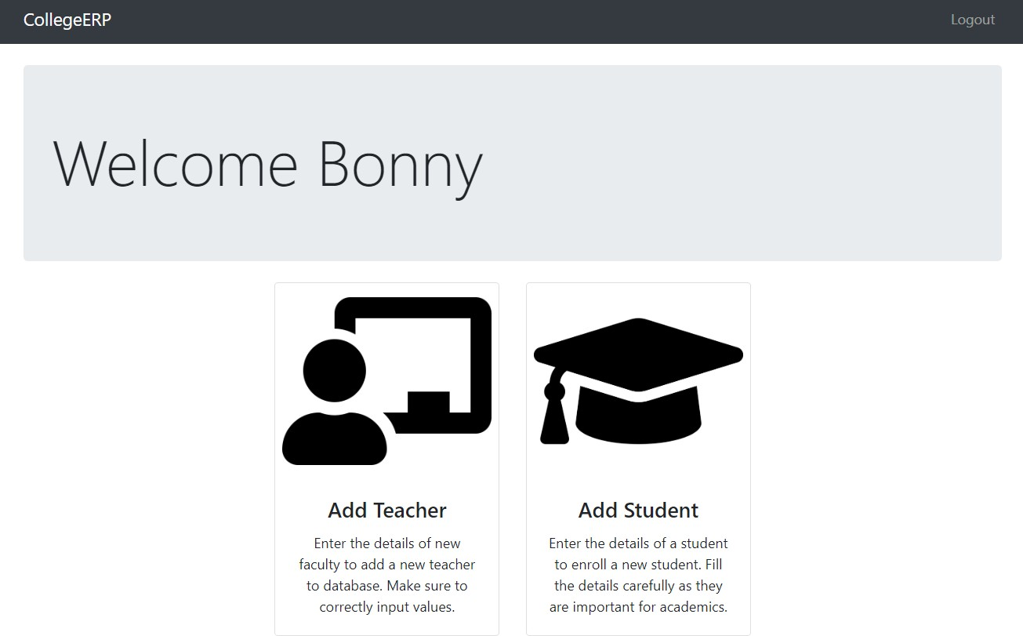

* + **Admin Section – Admin Panel**

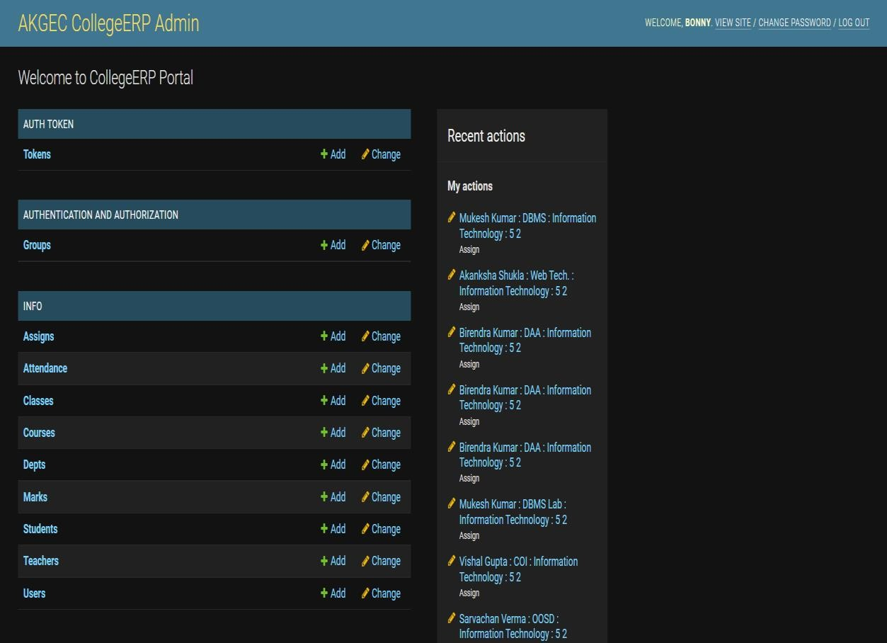

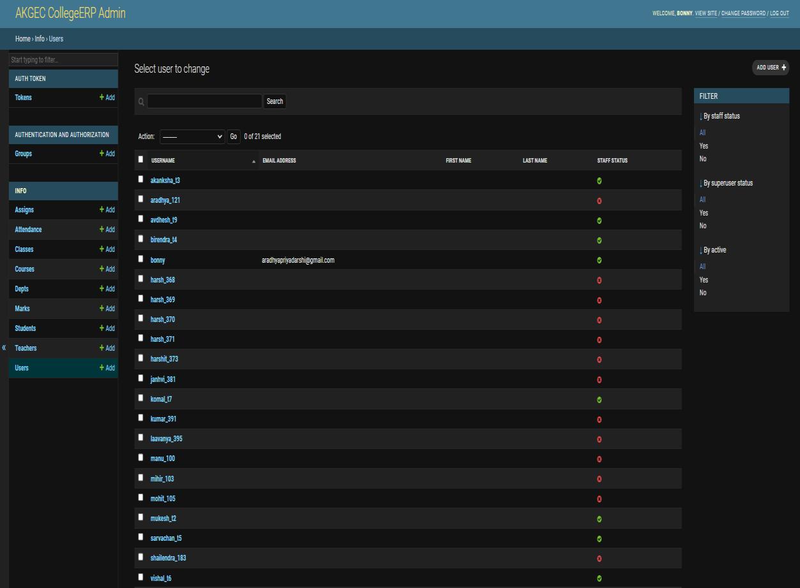

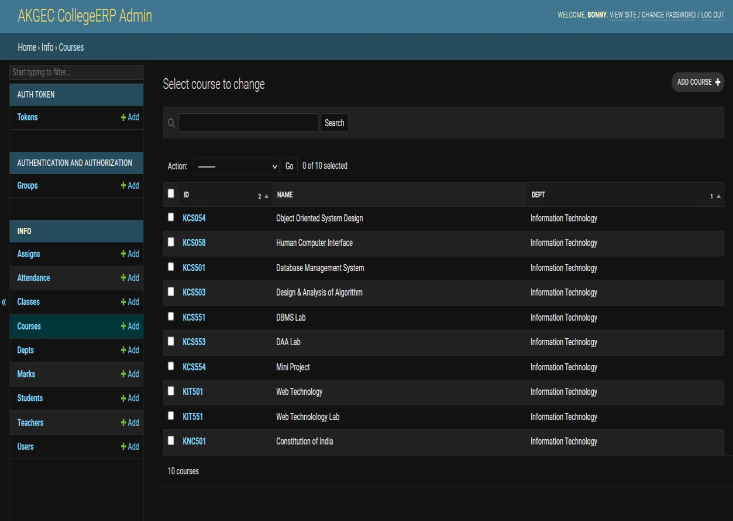

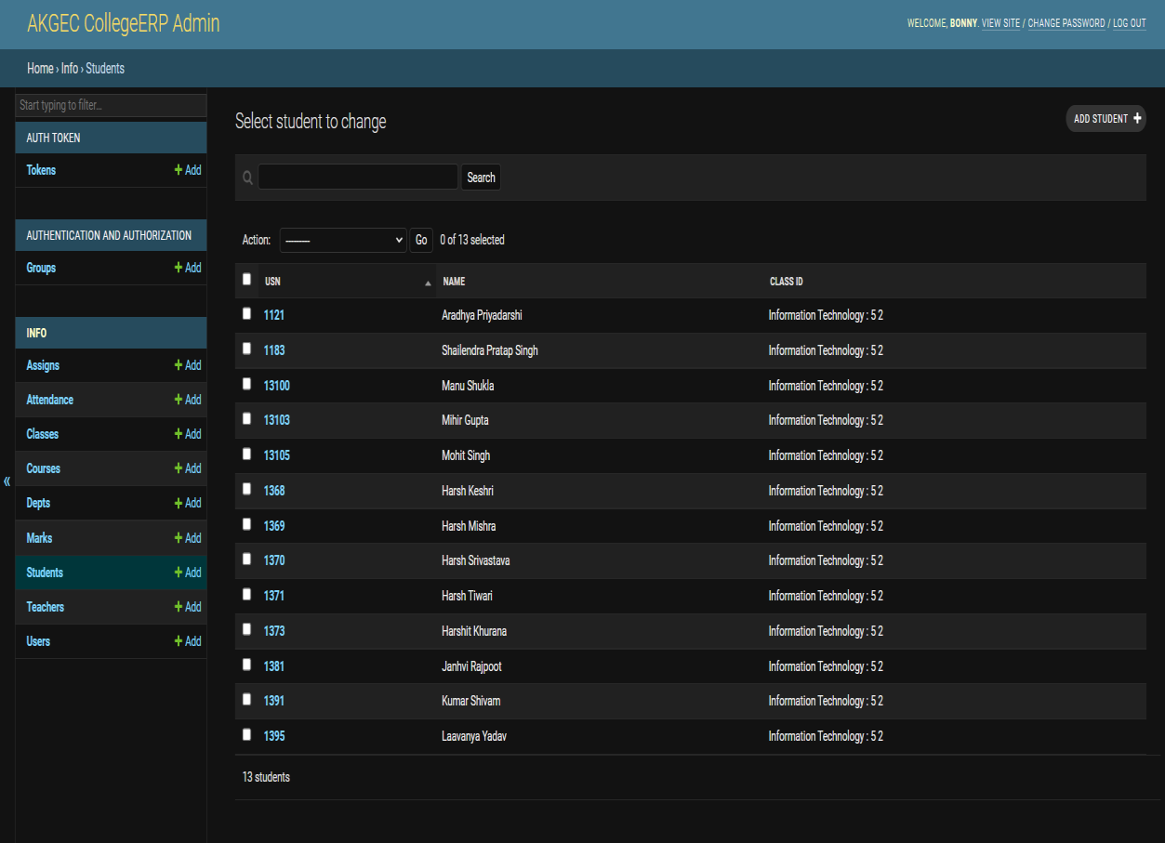

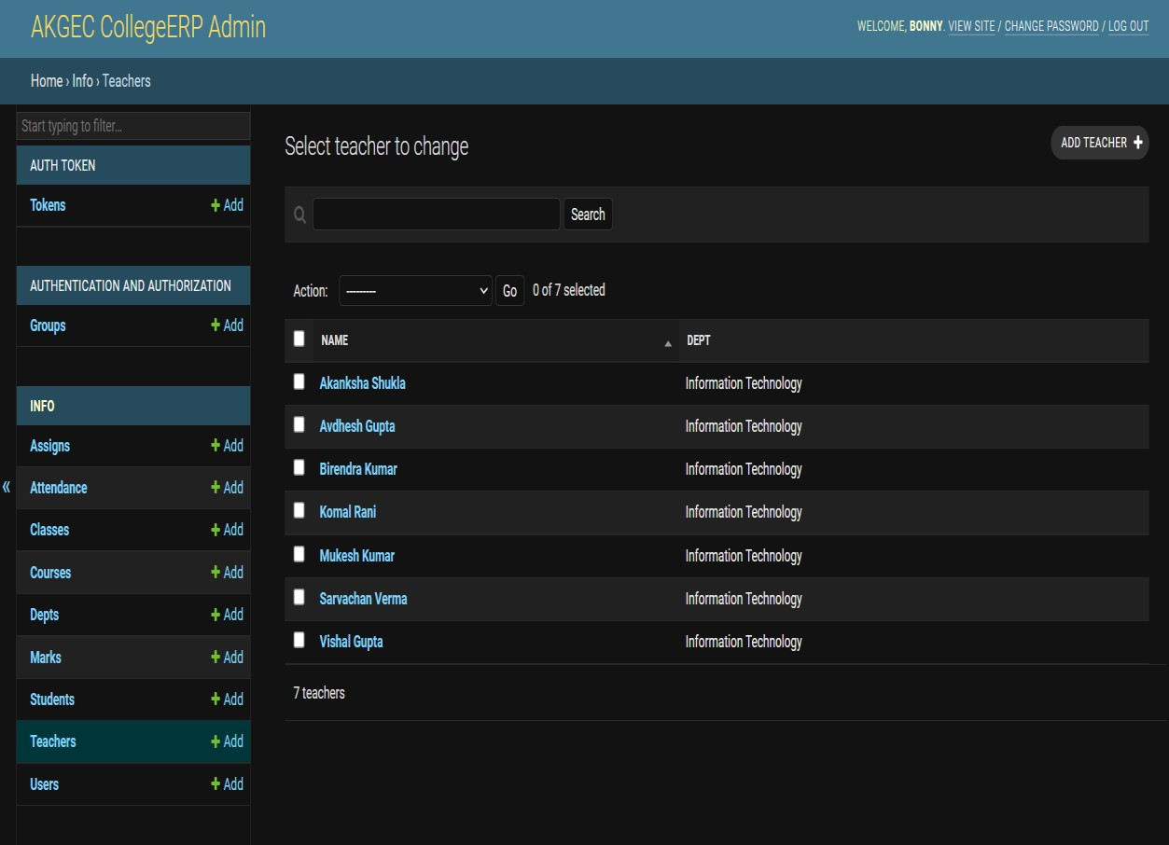

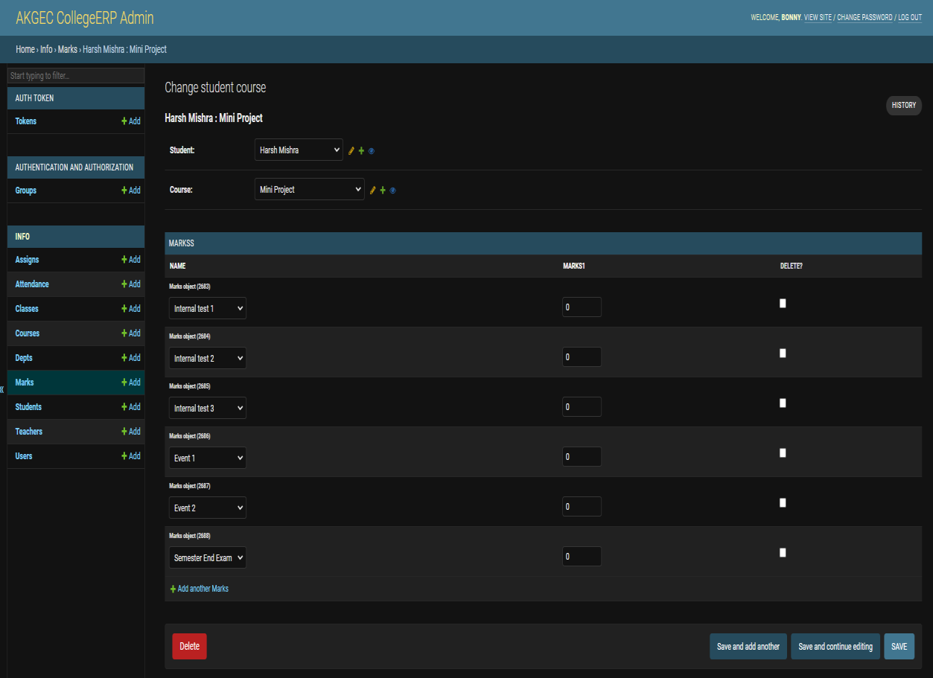

#### Student Section

This is the section where the students of the institution will be able to view their respective attendance record, marks & time table.

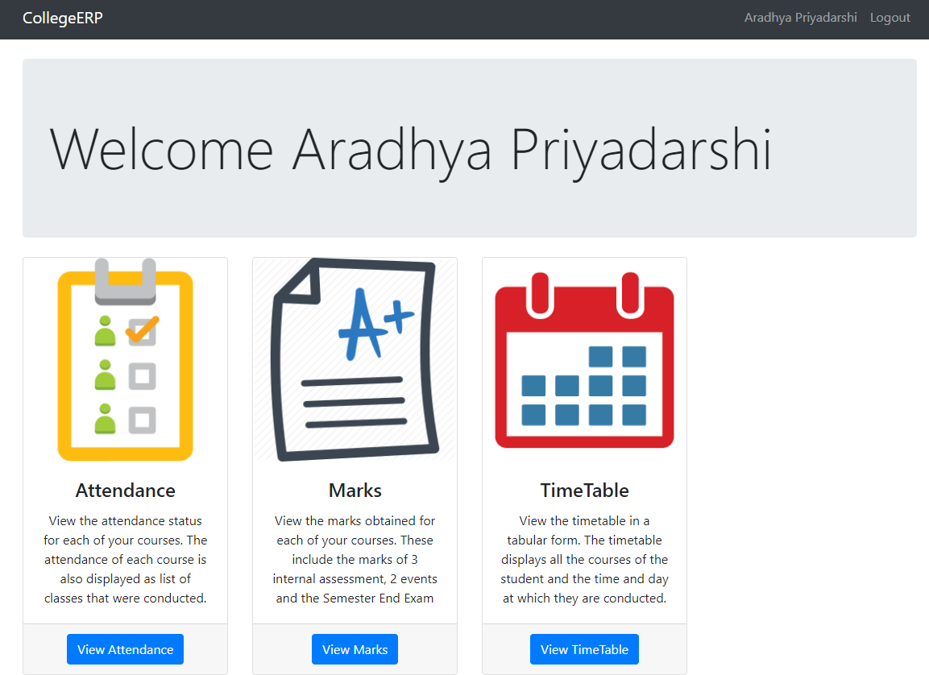

* **Student Section – Attendance Record**

Here, in this section ,the student will be able to view the respective attendance record in their subjects.

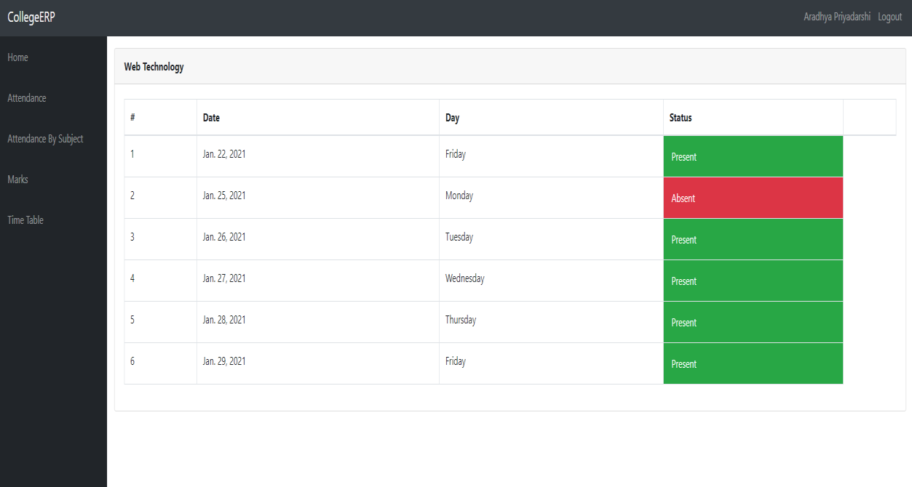

##### Student Section – Marks Obtained

Students will also be having the right of viewing their marks obtained record in each of their subjects.

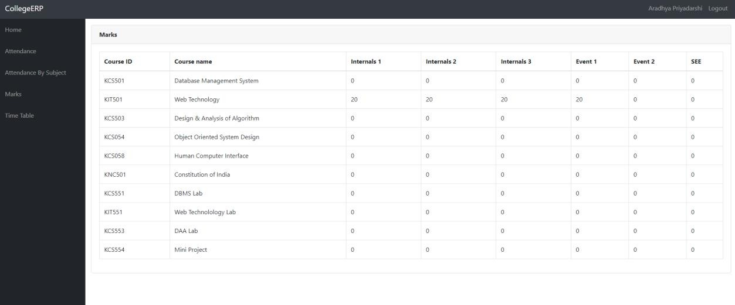

##### Student Section – Time Table

Time Table tells the student what subject needs to be learnt in which time slot. This is the backbone of any institution and makes the smooth running of any department.

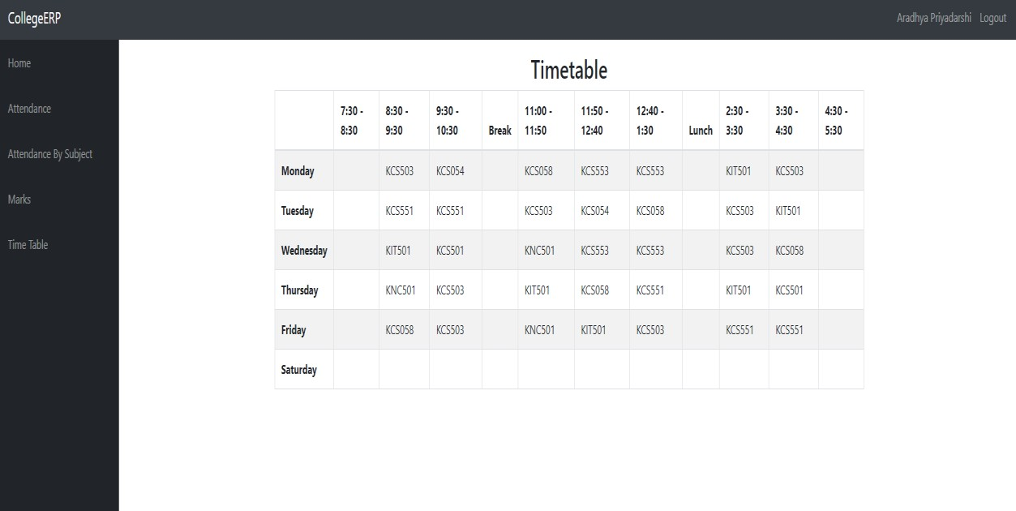

#### Teacher Section

Teacher section is having the right of read and writing the records of any student regarding attendance upload, marks upload, time table generation and generating the reports of any student.

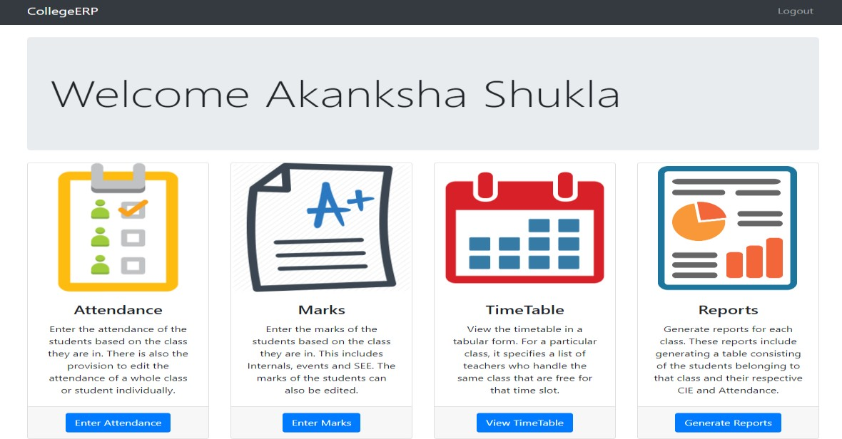

* **Teacher Section – Reading Attendance**

Here, the teacher will be able view the attendance percentage of each and every student of his/her class.

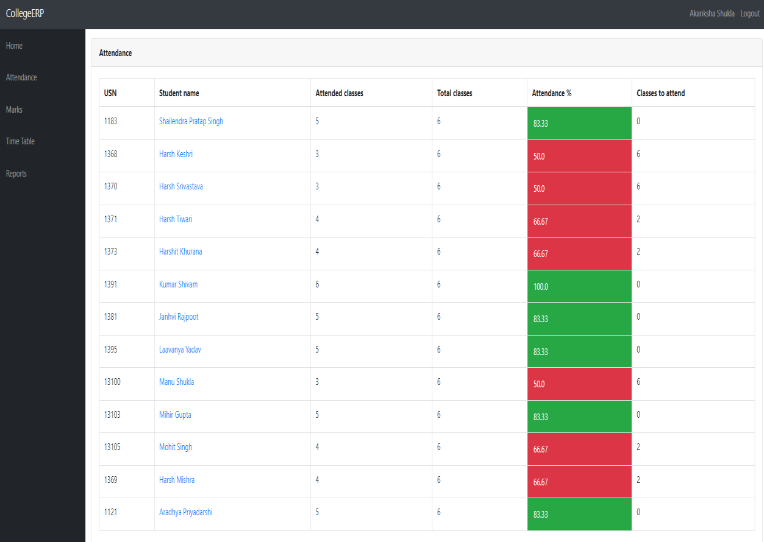

##### Teacher Section – Writing Attendance

Here, the teacher will be able write the attendance of each and every student of his/her class.

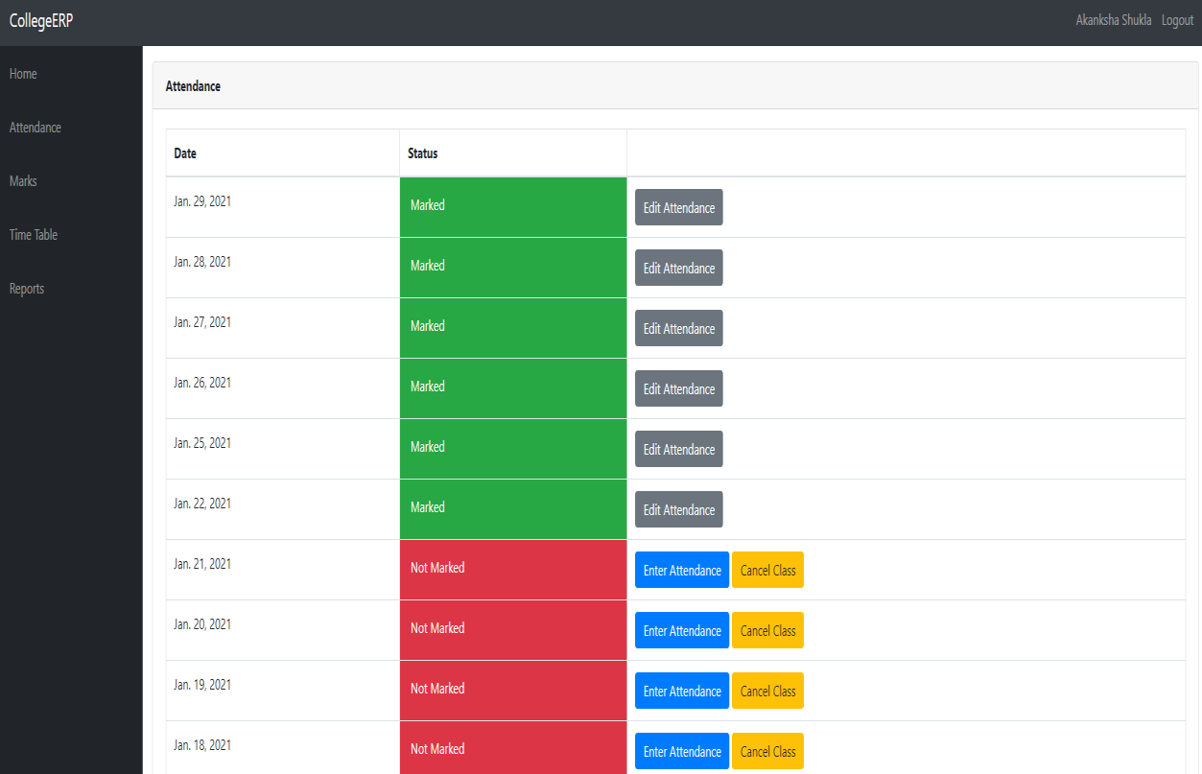

##### Teacher Section – Score Card of Every Student

Here, The teacher will be able to know which student has scored and how much in his/her subject.

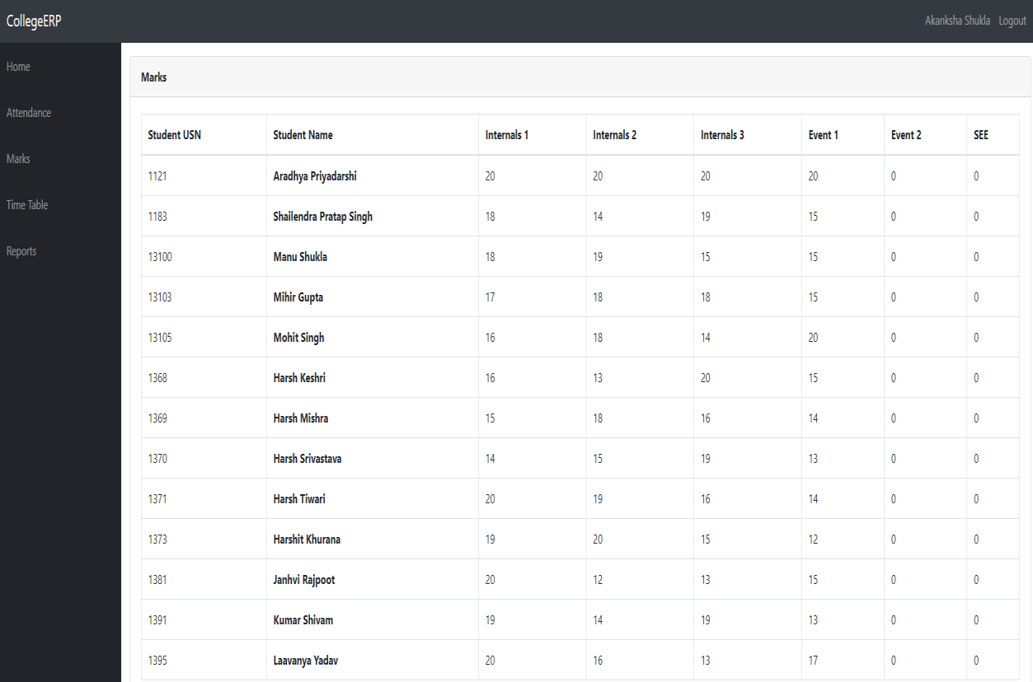

* **Teacher Section – Giving Marks to Students** Teacher will be able to give marks to each and every student based upon his performance.

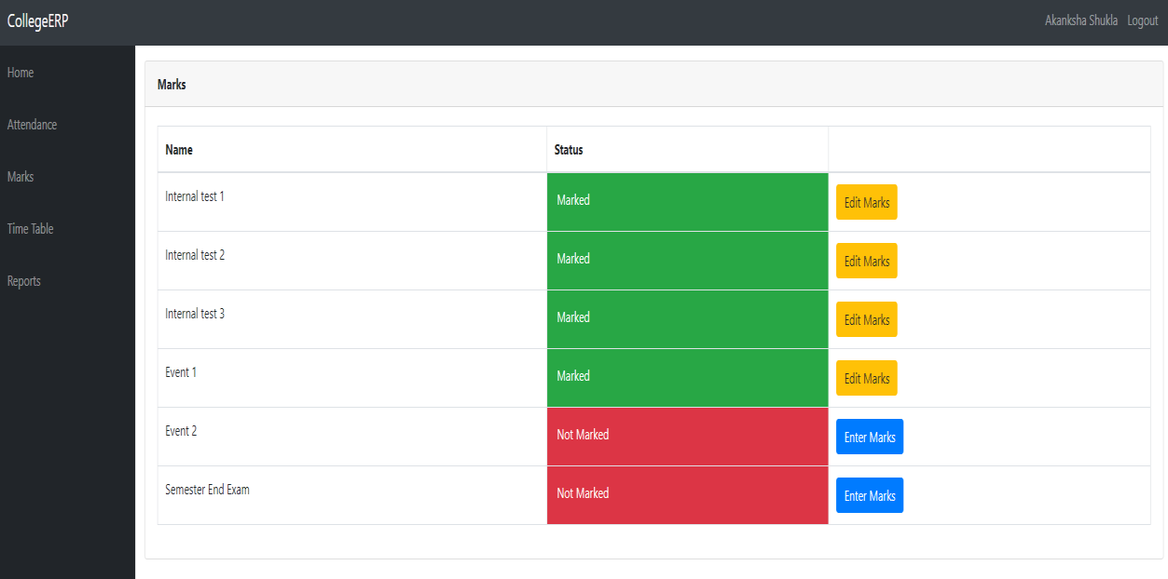

##### Teacher Section – Time Table

The teacher can also decide when to take the class or when to allot the lecture to the students

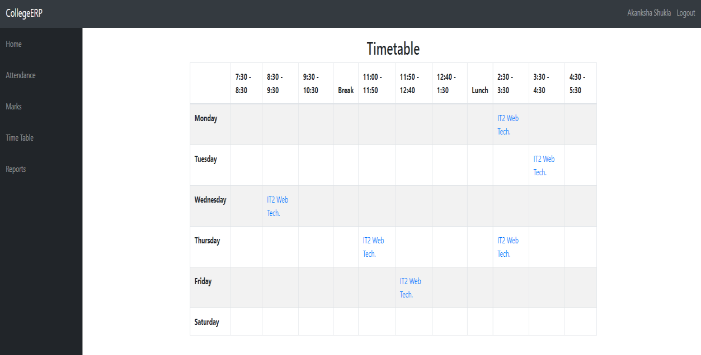

##### Teacher Section – Generating Reports

Teacher is superior to the students so he/she is having the right to generate the report of each and every student based upon his attendance percentage and previous academic records.

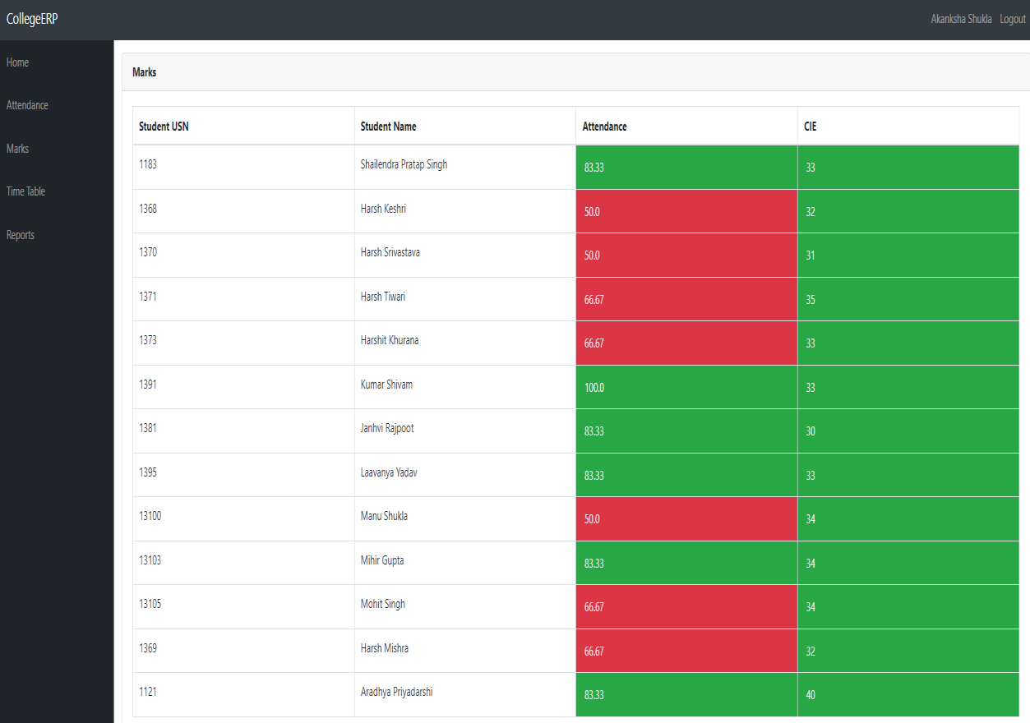

##### SOURCE CODE

EduSync Pro – CollegeERP System

<!DOCTYPE *html*>

<html *lang*="en">

<head>

<meta *charset*="UTF-8" />

<meta *http-equiv*="X-UA-Compatible" *content*="IE=edge" />

<meta *name*="viewport" *content*="width=device-width, initial- scale=1.0" />

<link

*href*="[https://unpkg.com/tailwindcss@^1.0/dist/tailwind.min.css](https://unpkg.com/tailwindcss%40)

"

*rel*="stylesheet"

/>

<title>EduSync Pro</title>

<link *rel* = "icon" *href* =

"https://img.freepik.com/free-vector/infinity-icon_1034- 617.jpg?w=740&t=st=1668369296~exp=1668369896~hmac=f9358d14f4822e4cdf 1b7c14be43902c21e4d4215e039f241ecae158187d3434"

*type* = "image/x-icon">

</head>

<body>

<header *class*="text-gray-600 body-font">

<div

*class*="container mx-auto flex flex-wrap p-5 flex-col md:flex-row items-center"

>

<a

*class*="flex title-font font-medium items-center text-gray-

900 mb-4 md:mb-0"

>

full"

<svg

*xmlns*="<http://www.w3.org/2000/svg>" *fill*="none"

*stroke*="currentColor" *stroke-linecap*="round" *stroke-linejoin*="round" *stroke-width*="2"

*class*="w-10 h-10 text-white p-2 bg-indigo-500 rounded-

*viewBox*="0 0 24 24"

*data-darkreader-inline-stroke*=""

*style*="--darkreader-inline-stroke: currentColor"

>

<path

10-5"

*d*="M12 2L2 7l10 5 10-5-10-5zM2 17l10 5 10-5M2 12l10 5

></path>

</svg>

<span *class*="ml-3 text-xl">EduSync Pro</span>

</a>

<nav

*class*="md:ml-auto flex flex-wrap items-center text-base

justify-center"

>

<a *class*="mr-5 hover:text-gray-900" *href*="[https://www.akgec.ac.in/](http://www.akgec.ac.in/)" *target*="_blank">AKGEC Website</a>

<a

*class*="mr-5 hover:text-gray-900"

*href*="https://accounts.google.com/v3/signin/identifier?d

sh=S168243120%3A1668369986192437&continue=https%3A%2F%2Fclassroom.go ogle.com%2Fu%2F0%2Fh&followup=https%3A%2F%2Fclassroom.google.com%2Fu

%2F0%2Fh&passive=1209600&service=classroom&flowName=GlifWebSignIn&fl owEntry=ServiceLogin&ifkv=ARgdvAtGhoKqWbZ1fXbvgua0_u2lqcjO6owcpFgBM0 iCLPcXd6j50noG0JqG2nd7UKvO0C_JAHM_"

*target*="_blank"

>Google Classroom

</a>

<a *class*="mr-5 hover:text-gray-900" *href*="[https://www.geeksforgeeks.org/](http://www.geeksforgeeks.org/)" *target*="_blank">GeeksForGeeks

</a>

<a *class*="mr-5 hover:text-gray-900"

*href*="[https://www.youtube.com](http://www.youtube.com/)"

*target*="_blank">YouTube</a>

</nav>

<button

*class*="inline-flex items-center bg-gray-100 border-0 py-1 px-3 focus:outline-none hover:bg-gray-200 rounded text-base mt-4 md:mt-0"

>

🙂

<svg

*fill*="none" *stroke*="currentColor" *stroke-linecap*="round" *stroke-linejoin*="round" *stroke-width*="2" *class*="w-4 h-4 ml-1" *viewBox*="0 0 24 24"

*data-darkreader-inline-stroke*=""

*style*="--darkreader-inline-stroke: currentColor

>

<path *d*="M5 12h14M12 5l7 7-7 7"></path>

</svg>

</button>

</div>

</header>

<hr />

<section *class*="text-gray-600 body-font">

<div *class*="container mx-auto flex px-5 py-24 items-center justify-center flex-col">

<img *class*="lg:w-2/6 md:w-3/6 w-5/6 mb-10 object-cover object-center rounded" *alt*="hero" *src*="https://source.unsplash.com/random/?Invention/720x600">

<div *class*="text-center lg:w-2/3 w-full">

<h1 *class*="title-font sm:text-4xl text-3xl mb-4 font- medium text-gray-900">H O L A !</h1>

<p *class*="mb-8 leading-relaxed">Innovation takes birth in sync with the evolution of customer’s expectations and demands or vice versa. Either way, organizations around the world have to continually innovate themselves and keep up with the people’s wants. The failure to do so or being indifferent to your customer’s need will make your competitors win. And then suddenly, customers become indifferent to you- a high-risk gamble to play at.</p>

</div>

</div>

</section>

<hr>

<section *class*="text-gray-600 body-font">

<div *class*="container px-5 py-24 mx-auto">

<div *class*="lg:w-2/3 flex flex-col sm:flex-row sm:items- center items-start mx-auto">

<h1 *class*="flex-grow sm:pr-16 text-2xl font-medium title- font text-gray-900">AKGEC CollegeERP</h1>

<a *class*="text-gray-600 hover:text-gray-800" *href*="https://web-production-853c.up.railway.app/" *target*="- blank">Click here to visit CollegeERP</a>

</div>

</div>

</section>

<hr>

<section *class*="text-gray-600 body-font">

<div

*class*="container mx-auto flex px-5 py-24 md:flex-row flex- col items-center"

>

<div

*class*="lg:flex-grow md:w-1/2 lg:pr-24 md:pr-16 flex flex- col md:items-start md:text-left mb-16 md:mb-0 items-center text- center"

>

<h1

*class*="title-font sm:text-4xl text-3xl mb-4 font-medium

text-gray-900"

>

missed your

Howdy! <br *class*="hidden lg:inline-block" />Have you

college today? Don't worry! Sit back & Relax *_*

<br *class*="hidden lg:inline-block" />Welcome to

MyStudyPartner ;)

</h1>

<p *class*="mb-8 leading-relaxed">

Jai Hind! Everyone, This is Aradhya Priyadarshi along with my Project partner Harsh Tiwari have made a project on a website that will make available all the notes and important topics about the academic related options. The name of the project is EduSync Pro.

</p>

</div>

<div *class*="lg:max-w-lg lg:w-full md:w-1/2 w-5/6">

<img

*class*="object-cover object-center rounded"

*alt*="hero" *src*="https://source.unsplash.com/random/?Notes/720x600"

/>

</div>

</div>

</section>

<hr>

<footer *class*="text-gray-600 body-font">

<div *class*="container px-5 py-24 mx-auto flex md:items-center lg:items-start md:flex-row md:flex-nowrap flex-wrap flex-col">

<div *class*="w-64 flex-shrink-0 md:mx-0 mx-auto text-center md:text-left">

<a *class*="flex title-font font-medium items-center md:justify-start justify-center text-gray-900">

<svg *xmlns*="<http://www.w3.org/2000/svg>" *fill*="none" *stroke*="currentColor" *stroke-linecap*="round" *stroke-linejoin*="round"

*stroke-width*="2" *class*="w-10 h-10 text-white p-2 bg-indigo-500 rounded-full" *viewBox*="0 0 24 24">

<path *d*="M12 2L2 7l10 5 10-5-10-5zM2 17l10 5 10-5M2

12l10 5 10-5"></path>

</svg>

<span *class*="ml-3 text-xl">Materials</span>

</a>

<p *class*="mt-2 text-sm text-gray-500">“A reader lives a thousand lives before he dies.” – George R. R. Martin</p>

</div>

<div *class*="flex-grow flex flex-wrap md:pl-20 -mb-10 md:mt-0 mt-10 md:text-left text-center">

<div *class*="lg:w-1/3 md:w-1/2 w-full px-3">

<h2 *class*="title-font font-medium text-gray-900 tracking-widest text-sm mb-3">CS</h2>

<nav *class*="list-none mb-10">

<li>

<a *class*="text-gray-600 hover:text-gray-800" *href*="https://drive.google.com/u/1/uc?id=1V6fkzZKzMRq3KIz5IANKrhllxZ vbpko6&export=download">1. Constitution of India - KNC501</a>

</li>

<li>

<a *class*="text-gray-600 hover:text-gray-800" *href*="https://drive.google.com/u/1/uc?id=12H5Spm95m7McdQJGsCOiUsH8ZK KLAhpv&export=download">2. Database Management System - KCS501</a>

</li>

<li>

<a *class*="text-gray-600 hover:text-gray-800" *href*="https://drive.google.com/u/1/uc?id=1tyQU53viRFqCuYztvOFD3f1VMO giaKA_&export=download">3. Design & Analysis of Algorithm - KCS503</a>

</li>

<li>

<a *class*="text-gray-600 hover:text-gray-800" *href*="https://drive.google.com/u/1/uc?id=1c0bctjBuV9nwpq9CNfLDE8ra2R M4wS7L&export=download">4. Human Computer Interface - KCS058</a>

</li>

<li>

<a *class*="text-gray-600 hover:text-gray-800" *href*="https://drive.google.com/u/1/uc?id=1FFeTet84Cr4QMcV5MPsJzOr_k4 ZTxnob&export=download">5. Compiler Design - KCS502</a>

</li>

<li>

<a *class*="text-gray-600 hover:text-gray-800" *href*="https://drive.google.com/u/1/uc?id=1WjPuLIHum3duXlZu6V4Ht9yX5I vouh37&export=download">6. Web Designing - KCS052</a>

</li>

</nav>

</div>

<div *class*="lg:w-1/3 md:w-1/2 w-full px-3">

<h2 *class*="title-font font-medium text-gray-900 tracking-widest text-sm mb-3">IT</h2>

<nav *class*="list-none mb-10">

<li>

<a *class*="text-gray-600 hover:text-gray-800" *href*="https://drive.google.com/u/1/uc?id=1V6fkzZKzMRq3KIz5IANKrhllxZ vbpko6&export=download">1. Constitution of India - KNC501</a>

</li>

<li>

<a *class*="text-gray-600 hover:text-gray-800" *href*="https://drive.google.com/u/1/uc?id=12H5Spm95m7McdQJGsCOiUsH8ZK KLAhpv&export=download">2. Database Management System - KCS501</a>

</li>

<li>

<a *class*="text-gray-600 hover:text-gray-800" *href*="https://drive.google.com/u/1/uc?id=1tyQU53viRFqCuYztvOFD3f1VMO giaKA_&export=download">3. Design & Analysis of Algorithm - KCS503</a>

</li>

<li>

<a *class*="text-gray-600 hover:text-gray-800" *href*="https://drive.google.com/u/1/uc?id=1c0bctjBuV9nwpq9CNfLDE8ra2R M4wS7L&export=download">4. Human Computer Interface - KCS058</a>

</li>

<li>

<a *class*="text-gray-600 hover:text-gray-800" *href*="https://drive.google.com/u/1/uc?id=1b56ZZIynY6RY- 3UiKQSyLetUmZq897XO&export=download">5. Object Oriented System Design - KCS054</a>

</li>

<li>

<a *class*="text-gray-600 hover:text-gray-800" *href*="https://drive.google.com/u/1/uc?id=1zE5EMkrOW- bsSgRyfMusYC6coxVu70Nf&export=download">6. Web Technology - KIT501</a>

</li>

</nav>

</div>

<div *class*="lg:w-1/3 md:w-1/2 w-full px-3">

<h2 *class*="title-font font-medium text-gray-900 tracking-widest text-sm mb-3">CSIT</h2>

<nav *class*="list-none mb-10">

<li>

<a *class*="text-gray-600 hover:text-gray-800" *href*="https://drive.google.com/u/1/uc?id=1V6fkzZKzMRq3KIz5IANKrhllxZ vbpko6&export=download">1. Constitution of India - KNC501</a>

</li>

<li>

<a *class*="text-gray-600 hover:text-gray-800" *href*="https://drive.google.com/u/1/uc?id=12H5Spm95m7McdQJGsCOiUsH8ZK KLAhpv&export=download">2. Database Management System - KCS501</a>

</li>

<li>

<a *class*="text-gray-600 hover:text-gray-800" *href*="https://drive.google.com/u/1/uc?id=1tyQU53viRFqCuYztvOFD3f1VMO giaKA_&export=download">3. Design & Analysis of Algorithm - KCS503</a>

</li>

<li>

<a *class*="text-gray-600 hover:text-gray-800" *href*="https://drive.google.com/u/1/uc?id=1c0bctjBuV9nwpq9CNfLDE8ra2R M4wS7L&export=download">4. Human Computer Interface - KCS058</a>

</li>

<li>

<a *class*="text-gray-600 hover:text-gray-800" *href*="https://drive.google.com/u/1/uc?id=1b56ZZIynY6RY- 3UiKQSyLetUmZq897XO&export=download">5. Object Oriented System Design - KCS054</a>

</li>

<li>

<a *class*="text-gray-600 hover:text-gray-800" *href*="https://drive.google.com/u/1/uc?id=1zE5EMkrOW- bsSgRyfMusYC6coxVu70Nf&export=download">6. Web Technology - KIT501</a>

</li>

</nav>

</div>

</div>

</div>

</footer>

<hr />

<section *class*="text-gray-600 body-font">

<div *class*="container px-5 py-24 mx-auto">

<div *class*="flex flex-wrap w-full mb-20 flex-col items- center text-center">

<h1 *class*="sm:text-3xl text-2xl font-medium title-font mb-

2 text-gray-900">Essential Websites</h1>

<p *class*="lg:w-1/2 w-full leading-relaxed text-gray- 500">“Measuring programming progress by lines of code is like measuring aircraft building progress by weight.”

– Bill Gates</p>

</div>

<div *class*="flex flex-wrap -m-4">

<div *class*="xl:w-1/3 md:w-1/2 p-4">

<div *class*="border border-gray-200 p-6 rounded-lg">

<div *class*="w-10 h-10 inline-flex items-center justify-center rounded-full bg-indigo-100 text-indigo-500 mb-4">

<svg *fill*="none" *stroke*="currentColor" *stroke- linecap*="round" *stroke-linejoin*="round" *stroke-width*="2" *class*="w-6 h-6" *viewBox*="0 0 24 24">

<path *d*="M22 12h-4l-3 9L9 3l-3 9H2"></path>

</svg>

</div>

<h2 *class*="text-lg text-gray-900 font-medium title- font mb-2">AKTU OneView</h2>

<p *class*="leading-relaxed text-base">AKTU Portal to view result</p>

<br />

<a *class*="text-gray-600 hover:text-gray-800" *href*="https://erp.aktu.ac.in/webpages/oneview/oneview.aspx" *target*="_blank">Click here to visit AKTU OneView</a>

</div>

</div>

<div *class*="xl:w-1/3 md:w-1/2 p-4">

<div *class*="border border-gray-200 p-6 rounded-lg">

<div *class*="w-10 h-10 inline-flex items-center justify-center rounded-full bg-indigo-100 text-indigo-500 mb-4">

<svg *fill*="none" *stroke*="currentColor" *stroke- linecap*="round" *stroke-linejoin*="round" *stroke-width*="2" *class*="w-6 h-6" *viewBox*="0 0 24 24">

<circle *cx*="6" *cy*="6" *r*="3"></circle>

<circle *cx*="6" *cy*="18" *r*="3"></circle>

<path *d*="M20 4L8.12 15.88M14.47 14.48L20 20M8.12 8.12L12 12"></path>

</svg>

</div>

<h2 *class*="text-lg text-gray-900 font-medium title- font mb-2">AKTU ERP</h2>

<p *class*="leading-relaxed text-base">AKTU Portal to manage your University data</p>

<br />

<a *class*="text-gray-600 hover:text-gray-800" *href*="https://erp.aktu.ac.in/" *target*="_blank">Click here to visit AKTU ERP</a>

</div>

</div>

<div *class*="xl:w-1/3 md:w-1/2 p-4">

<div *class*="border border-gray-200 p-6 rounded-lg">

<div *class*="w-10 h-10 inline-flex items-center justify-center rounded-full bg-indigo-100 text-indigo-500 mb-4">

<svg *fill*="none" *stroke*="currentColor" *stroke- linecap*="round" *stroke-linejoin*="round" *stroke-width*="2" *class*="w-6 h-6" *viewBox*="0 0 24 24">

<path *d*="M20 21v-2a4 4 0 00-4-4H8a4 4 0 00-4

4v2"></path>

<circle *cx*="12" *cy*="7" *r*="4"></circle>

</svg>

</div>

<h2 *class*="text-lg text-gray-900 font-medium title-

font mb-2">AKGEC Edumarshal</h2>

<p *class*="leading-relaxed text-base">AKGEC Portal to manage your College data</p>

<br />

<a *class*="text-gray-600 hover:text-gray-800" *href*="https://beta.edumarshal.com/" *target*="_blank">Click here to visit Edumarshal</a>

</div>

</div>

</div>

</div>

</section>

<hr />

<section *class*="text-gray-600 body-font">

<div *class*="container px-5 py-24 mx-auto">

<div *class*="flex flex-col text-center w-full mb-20">

<h1

*class*="text-2xl font-medium title-font mb-4 text-gray- 900 tracking-widest"

>

OUR TEAM

</h1>

<p *class*="lg:w-2/3 mx-auto leading-relaxed text-base">

When the ideas are coming, we don't stop until the ideas stop because that train doesn't come along all the time.

</p>

</div>

<div *class*="flex flex-wrap -m-4">

<div *class*="p-4 lg:w-1/2">

<div

*class*="h-full flex sm:flex-row flex-col items-center sm:justify-start justify-center text-center sm:text-left"

>

<img

*alt*="team"

*class*="flex-shrink-0 rounded-lg w-48 h-48 object- cover object-center sm:mb-0 mb-4"

900">

*src*="Aradhya1.jpeg"

/>

<div *class*="flex-grow sm:pl-8">

<h2 *class*="title-font font-medium text-lg text-gray-

Aradhya Priyadarshi

</h2>

<h3 *class*="text-gray-500 mb-3">MERN Developer</h3>

<p *class*="mb-4">

If there was an observer on Mars, they would

probably be amazed that we have survived this long.

</p>

<span *class*="inline-flex">

<a *class*="text-gray-500" *href*="[https://www.facebook.com/aradhya.priyadarshi](http://www.facebook.com/aradhya.priyadarshi)

"

*target*="_blank">

<svg

*fill*="none" *stroke*="currentColor" *stroke-linecap*="round" *stroke-linejoin*="round" *stroke-width*="2" *class*="w-5 h-5" *viewBox*="0 0 24 24"

>

4h-4V7a1 1 0 011-1h3z"

<path

*d*="M18 2h-3a5 5 0 00-5 5v3H7v4h3v8h4v-8h3l1-

></path>

</svg>

</a>

<a *class*="ml-2 text-gray-500" *href*="https://twitter.com/AradhyA360" *target*="_blank">

<svg

*fill*="none" *stroke*="currentColor" *stroke-linecap*="round" *stroke-linejoin*="round" *stroke-width*="2" *class*="w-5 h-5" *viewBox*="0 0 24 24"

>

<path

*d*="M23 3a10.9 10.9 0 01-3.14 1.53 4.48 4.48

0 00-7.86 3v1A10.66 10.66 0 013 4s-4 9 5 13a11.64 11.64 0 01-7 2c9 5

20 0 20-11.5a4.5 4.5 0 00-.08-.83A7.72 7.72 0 0023 3z"

></path>

</svg>

</a>

<a *class*="ml-2 text-gray-500"

*href*="https://wa.me/+918808907500" *target*="_blank">

<svg

*fill*="none" *stroke*="currentColor" *stroke-linecap*="round" *stroke-linejoin*="round" *stroke-width*="2" *class*="w-5 h-5" *viewBox*="0 0 24 24"

>

<path

*d*="M21 11.5a8.38 8.38 0 01-.9 3.8 8.5 8.5 0

01-7.6 4.7 8.38 8.38 0 01-3.8-.9L3 21l1.9-5.7a8.38 8.38 0 01-.9-3.8

8.5 8.5 0 014.7-7.6 8.38 8.38 0 013.8-.9h.5a8.48 8.48 0 018 8v.5z"

></path>

</svg>

</a>

</span>

</div>

</div>

</div>

<div *class*="p-4 lg:w-1/2">

<div

*class*="h-full flex sm:flex-row flex-col items-center sm:justify-start justify-center text-center sm:text-left"

>

<img

*alt*="team"

*class*="flex-shrink-0 rounded-lg w-48 h-48 object- cover object-center sm:mb-0 mb-4"

*src*="Harsh.png"

/>

<div *class*="flex-grow sm:pl-8">

<h2 *class*="title-font font-medium text-lg text-gray-

900">

Harsh Tiwari

</h2>

<h3 *class*="text-gray-500 mb-3">Designer</h3>

<p *class*="mb-4">

If you're teaching today what you were teaching

five years ago, either the field is dead or you are.

</p>

<span *class*="inline-flex">

<a *class*="text-gray-500">

<svg

*fill*="none" *stroke*="currentColor" *stroke-linecap*="round" *stroke-linejoin*="round" *stroke-width*="2" *class*="w-5 h-5" *viewBox*="0 0 24 24"

>

4h-4V7a1 1 0 011-1h3z"

<path

*d*="M18 2h-3a5 5 0 00-5 5v3H7v4h3v8h4v-8h3l1-

></path>

</svg>

</a>

<a *class*="ml-2 text-gray-500">

<svg

*fill*="none" *stroke*="currentColor" *stroke-linecap*="round" *stroke-linejoin*="round" *stroke-width*="2" *class*="w-5 h-5" *viewBox*="0 0 24 24"

>

<path

*d*="M23 3a10.9 10.9 0 01-3.14 1.53 4.48 4.48

0 00-7.86 3v1A10.66 10.66 0 013 4s-4 9 5 13a11.64 11.64 0 01-7 2c9 5

20 0 20-11.5a4.5 4.5 0 00-.08-.83A7.72 7.72 0 0023 3z"

></path>

</svg>

</a>

<a *class*="ml-2 text-gray-500"

*href*="https://wa.me/+918802690075" *target*="_blank">

<svg

*fill*="none" *stroke*="currentColor" *stroke-linecap*="round" *stroke-linejoin*="round" *stroke-width*="2" *class*="w-5 h-5" *viewBox*="0 0 24 24"

>

<path

*d*="M21 11.5a8.38 8.38 0 01-.9 3.8 8.5 8.5 0

01-7.6 4.7 8.38 8.38 0 01-3.8-.9L3 21l1.9-5.7a8.38 8.38 0 01-.9-3.8

8.5 8.5 0 014.7-7.6 8.38 8.38 0 013.8-.9h.5a8.48 8.48 0 018 8v.5z"

></path>

</svg>

</a>

</span>

</div>

</div>

</div>

</section>

<hr />

<section *class*="text-gray-600 body-font relative">

<div *class*="container px-5 py-24 mx-auto">

<div *class*="flex flex-col text-center w-full mb-12">

<h1

*class*="sm:text-3xl text-2xl font-medium title-font mb-4 text-gray-900"

>

Contact Us

</h1>

<p *class*="lg:w-2/3 mx-auto leading-relaxed text-base"> If you're having any issue regarding the contents of

this page,

please do e-mail us for faster resolution !

</p>

</div>

<div

*class*="p-2 w-full pt-8 mt-8 border-t border-gray-200

text-center"

>

<a *class*="text-indigo-500"

*href*="[mailto:aradhyaaa@hotmail.com?subject=Contact](mailto:aradhyaaa@hotmail.com) Us%20">[aradhyaaa@hotmail.com](mailto:aradhyaaa@hotmail.com)</a>

<p *class*="leading-normal my-5">

47, Shyamanagar Colony <br />KKM, Varanasi, UP

221106

</p>

<span *class*="inline-flex">

<a

*class*="text-gray-500" *href*="[https://www.facebook.com/aradhya.priyadarshi](http://www.facebook.com/aradhya.priyadarshi)

"

*target*="_blank"

>

<svg

*fill*="currentColor" *stroke-linecap*="round" *stroke-linejoin*="round"

*stroke-width*="2" *class*="w-5 h-5" *viewBox*="0 0 24 24"

>

<path

*d*="M18 2h-3a5 5 0 00-5 5v3H7v4h3v8h4v-8h3l1-

4h-4V7a1 1 0 011-1h3z"

></path>

</svg>

</a>

<a

*class*="ml-4 text-gray-500" *href*="https://twitter.com/AradhyA360" *target*="_blank"

>

<svg

*fill*="currentColor" *stroke-linecap*="round" *stroke-linejoin*="round" *stroke-width*="2" *class*="w-5 h-5" *viewBox*="0 0 24 24"

>

<path

*d*="M23 3a10.9 10.9 0 01-3.14 1.53 4.48 4.48 0

00-7.86 3v1A10.66 10.66 0 013 4s-4 9 5 13a11.64 11.64 0 01-7 2c9 5

20 0 20-11.5a4.5 4.5 0 00-.08-.83A7.72 7.72 0 0023 3z"

></path>

</svg>

</a>

<a

i/"

*class*="ml-4 text-gray-500"

*href*="[https://www.instagram.com/aradhya.priyadarsh](http://www.instagram.com/aradhya.priyadarsh)

*target*="_blank"

>

<svg

*fill*="none" *stroke*="currentColor" *stroke-linecap*="round" *stroke-linejoin*="round" *stroke-width*="2" *class*="w-5 h-5" *viewBox*="0 0 24 24"

>

<rect

*width*="20" *height*="20"

11.37zm1.5-4.87h.01"

*x*="2"

*y*="2"

*rx*="5"

*ry*="5"

></rect>

<path

*d*="M16 11.37A4 4 0 1112.63 8 4 4 0 0116

></path>

</svg>

</a>

<a *class*="ml-4 text-gray-500" *href*="https://wa.me/+918808907500" *target*="_blank">

<svg *fill*="currentColor" *stroke-linecap*="round" *stroke-linejoin*="round" *stroke-width*="2" *class*="w-5 h-5" *viewBox*="0 0 24 24">

<path *d*="M21 11.5a8.38 8.38 0 01-.9 3.8 8.5 8.5

0 01-7.6 4.7 8.38 8.38 0 01-3.8-.9L3 21l1.9-5.7a8.38 8.38 0 01-.9-

3.8 8.5 8.5 0 014.7-7.6 8.38 8.38 0 013.8-.9h.5a8.48 8.48 0 018

8v.5z"></path>

</svg>

</a>

</span>

</div>

</div>

</div>

</div>

</section>

<hr />

<footer *class*="text-gray-600 body-font">

<div

*class*="container px-5 py-8 mx-auto flex items-center sm:flex-row flex-col"

>

<a

*class*="flex title-font font-medium items-center

md:justify-start justify-center text-gray-900"

>

<svg

*xmlns*="<http://www.w3.org/2000/svg>" *fill*="none"

*stroke*="currentColor" *stroke-linecap*="round" *stroke-linejoin*="round" *stroke-width*="2"

full"

10-5"

*class*="w-10 h-10 text-white p-2 bg-indigo-500 rounded-

*viewBox*="0 0 24 24"

>

<path

*d*="M12 2L2 7l10 5 10-5-10-5zM2 17l10 5 10-5M2 12l10 5

></path>

</svg>

<span *class*="ml-3 text-xl">BonnyXD</span>

</a>

<p

*class*="text-sm text-gray-500 sm:ml-4 sm:pl-4 sm:border-l-2 sm:border-gray-200 sm:py-2 sm:mt-0 mt-4"

>

© 2022 Aradhya Priyadarshi —

<a

*href*="https://twitter.com/AradhyA360" *class*="text-gray-600 ml-1" *rel*="noopener noreferrer" *target*="_blank"

>@AradhyA360</a

>

</p>

<span

*class*="inline-flex sm:ml-auto sm:mt-0 mt-4 justify-center sm:justify-start"

>

<a

*class*="text-gray-500" *href*="[https://www.facebook.com/aradhya.priyadarshi](http://www.facebook.com/aradhya.priyadarshi)" *target*="_blank"

>

<svg

*fill*="currentColor" *stroke-linecap*="round" *stroke-linejoin*="round" *stroke-width*="2" *class*="w-5 h-5" *viewBox*="0 0 24 24"

>

1 0 011-1h3z"

<path

*d*="M18 2h-3a5 5 0 00-5 5v3H7v4h3v8h4v-8h3l1-4h-4V7a1

></path>

</svg>

</a>

<a

*class*="ml-3 text-gray-500" *href*="https://twitter.com/AradhyA360" *target*="_blank"

>

<svg

*fill*="currentColor" *stroke-linecap*="round" *stroke-linejoin*="round" *stroke-width*="2" *class*="w-5 h-5" *viewBox*="0 0 24 24"

>

<path

*d*="M23 3a10.9 10.9 0 01-3.14 1.53 4.48 4.48 0 00-

7.86 3v1A10.66 10.66 0 013 4s-4 9 5 13a11.64 11.64 0 01-7 2c9 5 20 0

20-11.5a4.5 4.5 0 00-.08-.83A7.72 7.72 0 0023 3z"

></path>

</svg>

</a>

<a

*class*="ml-3 text-gray-500" *href*="[https://www.instagram.com/aradhya.priyadarshi/](http://www.instagram.com/aradhya.priyadarshi/)" *target*="_blank"

>

<svg

*fill*="none" *stroke*="currentColor" *stroke-linecap*="round" *stroke-linejoin*="round" *stroke-width*="2" *class*="w-5 h-5" *viewBox*="0 0 24 24"

>

*ry*="5"></rect>

4.87h.01"

<rect *width*="20" *height*="20" *x*="2" *y*="2" *rx*="5"

<path

*d*="M16 11.37A4 4 0 1112.63 8 4 4 0 0116 11.37zm1.5-

></path>

</svg>

</a>

<a

121782201/"

>

*class*="ml-3 text-gray-500"

*href*="[https://www.linkedin.com/in/aradhya](http://www.linkedin.com/in/aradhya-priyadarshi-)-[priyadarshi](http://www.linkedin.com/in/aradhya-priyadarshi-)- *target*="_blank"

<svg

*fill*="currentColor" *stroke*="currentColor" *stroke-linecap*="round" *stroke-linejoin*="round" s*troke-width*="0" *class*="w-5 h-5" *viewBox*="0 0 24 24"

>

<path

*stroke*="none"

*d*="M16 8a6 6 0 016 6v7h-4v-7a2 2 0 00-2-2 2 2 0 00-2

2v7h-4v-7a6 6 0 016-6zM2 9h4v12H2z"

></path>

<circle *cx*="4" *cy*="4" *r*="2" *stroke*="none"></circle>

</svg>

</a>

</span>

</div>

</footer>

</body>

</html>

##### CONCLUSION

By using Existing System accessing information from _les is a difficult task and there is no quick and easy way to keep the records of students and staff. Lack of automation is also there in the Existing System. The aim of Our System is to reduce the workload and to save significant standard time.

Tittle of the project as EduSync Pro - CollegeERP System is the system that deals with the issues related to a particular institution. It is the very useful to the student as well as the faculties to easy access to finding the details. The college ERP provides appropriate information to users based on their profiles and role in the system. This project is designed keeping in view the day to day problems faced by a college system.

The fundamental problem in maintaining and managing the work by the administrator is hence over- come. Prior to this it was a bit difficult for maintaining the time table and also keeping track of the daily schedule. But by developing this web-based application the administrator can enjoy the task, doing it ease and also by saving the valuable time. The amount of time consumption is reduced and also the manual calculations are omitted, the reports can be obtained regularly and also whenever on demand by the user. The effective utilization of the work, by proper sharing it and by providing the accurate results. The storage facility will ease the job of the operator. Thus the system developed will be helpful to the administrator by easing his/her task.

This System provide the automate admissions no manual processing is required. This is a paperless work. It can be monitored and controlled remotely. It reduces the man power required. It provides accurate information always. All years together gathered information can be saved and can be accessed at any time. The data which is stored in the repository helps in taking intelligent decisions by the management providing the accurate results. The storage facility will ease the job of the operator. Thus the system developed will be helpful to the administrator by easing his/her task providing the accurate results. The storage facility will ease the job of the operator.

This project is successfully implemented with all the features and modules of the college management system as per requirements.

##### REFERENCES

1. Elmasri and Navathe: Fundamentals of Database Systems 7th Edition
2. Ian Sommerville: Software Engineering, 10th edition
3. Roger S Pressman: Software Engineering- A Practitioners
4. https://en.wikipedia.org/wiki/Requirements-engineering
5. https://web.cs.dal.ca/ hawkey/3130/srs-template-ieee.doc
6. [http://www.ntu.edu.sg/home/cfcavallaro/Reports/Report%2](http://www.ntu.edu.sg/home/cfcavallaro/Reports/Report%252)
7. https://en.wikipedia.org/wiki/Class diagram
8. <https://www.djangoproject.com/>
9. <https://www.tutorialspoint.com/>
10. <https://creately.com/>
11. https://[www.overleaf.com/project](http://www.overleaf.com/project)